Part 1

2(a) d

2(b) t

2(c) d

2(d) e

2(e) d

2(f) q

3(a)

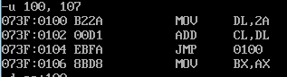

3(b)

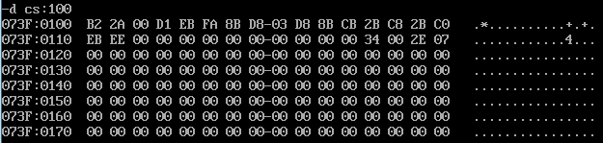

3(c)

Nothing

3(d)



4(a)



4(b)

Error

5(a)

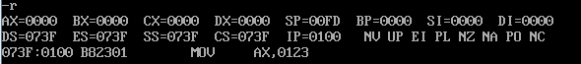

5(b)

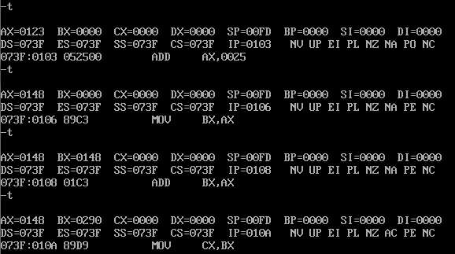

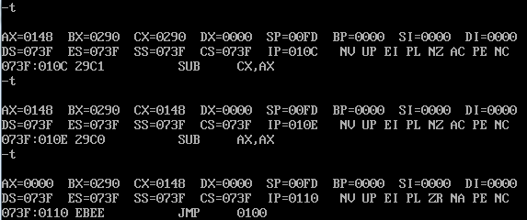

6



7

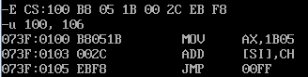

**Part 2**

1

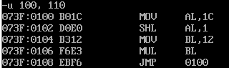

1(a) B0 1C MOV AL, 1C

1(b) D0 E0 SHL 1L, 1

1(c) B3 12 MOV BL, 12

1(d)F6 E3 MUL BL

1(e) EB EE JMP 0100

2 ax: 0050

3.ax=0141, dx= 0000

4.ax = 0080, dx = 0003

5a. A0

5b. FA

5c. 5A

5d. 55

6

Ax:0008 bx:0000  
Ax:0004 bx:0000

Ax:0004 bx:0000

Ax:0004 bx:0000

Part 3

1.

|  |  |  |  |
| --- | --- | --- | --- |
| Ax | Bx | Cx | Dx |
| 0030 | 0021 | Ffff | 0000 |
| 0010 | 0021 | Ffff | 0000 |
| 0010 | 0020 | Ffff | 0000 |
| 0010 | 0020 | 0030 | 0000 |
| 0030 | 0020 | 0030 | 0000 |
| 0030 | 0021 | 0030 | 0000 |
| 0030 | 0021 | 0000 | 0000 |
| 0030 | 0021 | Ffff | 0000 |

2.

|  |  |  |  |  |
| --- | --- | --- | --- | --- |
|  | Ax | Bx | Cx | Dx |
|  | 1 | 1 | 5 | 0 |
| 1st loop | 0001 | 0002 | 0005 | 0002 |
| 2nd loop | 0002 | 0003 | 0005 | 0003 |
| 3rd loop | 0003 | 0005 | 0005 | 0005 |
| 4th loop | 0005 | 0008 | 0005 | 0008 |
| 5th loop | 0008 | 000d | 0005 | 000d |

3.

|  |  |  |
| --- | --- | --- |
| Ax | Bx | Cx |
| 0010 | 0000 | 0000 |
| 0010 | 0020 | 0000 |
| 0010 | 0020 | 0030 |
| 0030 | 0020 | 0030 |
| 0030 | 0021 | 0030 |
| 0030 | 0021 | 0000 |
| 0030 | 0021 | Ffff |
| 0030 | 0021 | ffff |

4.ax = 0900, bx=0000, cx=0000, dx=0102

5.AX=0003,bx =0006

6.ax=0004,bx=000a